

Year 11 Units 1 & 2 Examination, 2018

Question/Answer Booklet

CHEMISTRY

Student Name: ______________________________________________

Teacher Name: ANSWERS

Time allowed for this paper
Reading time before commencing work: ten minutes
Working time for paper: three hours

Materials required/recommended for this paper

To be provided by the supervisor
This Question/Answer Booklet
Multiple-choice Answer Sheet
Chemistry Data Sheet

To be provided by the candidate
Standard items: pens (blue/black preferred), pencils (including coloured), sharpener, correction tape/fluid, eraser, ruler, highlighters
Special items: up to three non-programmable calculators approved for use in the ATAR examinations

Important note to candidates
No other items may be taken into the examination room. It is your responsibility to ensure that you do not have any unauthorised notes or other items of a non-personal nature in the examination room. If you have any unauthorised material with you, hand it to the supervisor before reading any further.
Structure of this paper

Section | Number of questions available | Number of questions to be answered | Suggested working time  (minutes) | Marks available | Percentage of examination
Section One:  Multiple-choice | 25 | 25 | 50 | 50 | 25
Section Two:  Short answer | 8 | 8 | 60 | 70 | 35
Section Three:  Extended answer | 4 | 4 | 70 | 80 | 40
Total |  |  |  |  | 100

Instructions to candidates

1. Answer the questions according to the following instructions.

Section One: Answer all questions on the separate Multiple-choice Answer Sheet provided. For each question shade the box to indicate your answer. Use only a blue or black pen to shade the boxes. If you make a mistake, place a cross through that square, do not erase or use correction fluid, and shade your new answer. Marks will not be deducted for incorrect answers. No marks will be given if more than one answer is completed for any question.

Sections Two and Three: Write answers in this Question/Answer Booklet.

3. When calculating numerical answers, show your working or reasoning clearly. Express numerical answers to the appropriate number of significant figures and include appropriate units where applicable

4. You must be careful to confine your responses to the specific questions asked and to follow any instructions that are specific to a particular question.

5. Spare pages are included at the end of this booklet. They can be used for planning your responses and/or as additional space if required to continue an answer.
• Planning: If you use the spare pages for planning, indicate this clearly at the top of the page.
• Continuing an answer: If you need to use the space to continue an answer, indicate in the original answer space where the answer is continued, i.e. give the page number. Fill in the number of the question that you are continuing to answer at the top of the page.
Section One: Multiple-choice 25% (25 Marks)

This section has 25 questions. Answer all questions on the separate Multiple-choice Answer Sheet provided. For each question shade the box to indicate your answer. Use only a blue or black pen to shade the boxes. If you make a mistake, place a cross through that square, do not erase or use correction fluid, and shade your new answer. Marks will not be deducted for incorrect answers. No marks will be given if more than one answer is completed for any question.

Suggested working time: 50 minutes.

1. As we move across a period in the periodic table form left to right:

- The atomic radii of the elements increases
- The metallic character of the elements increases
(c) the number of electron shells in each element increases
(d) the tendency of each element to gain electrons increases

2. The electron configuration for potassium is:

(a) 1s² 2s² 2p⁶ 3s² 3p⁶ 4s¹
(b) 1s² 2s² 2p⁸ 3s¹ 3p⁶
(c) 1s² 2s² 2p⁶ 3s² 3p⁶ 4s²
(d) 1s² 2s⁸ 3s⁸ 4s¹

3. Which one of the following is the correct name for the compound shown below?

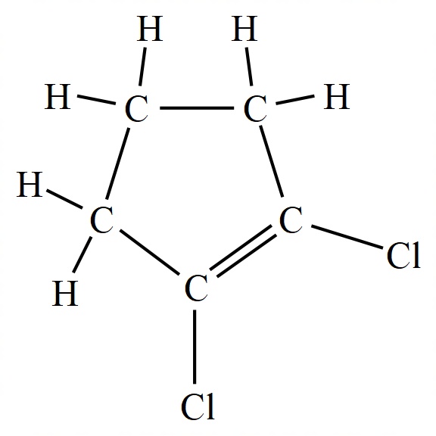

(a) 1,2-dichlorocyclopentane
(b) 1,2-dichlorocyclopentene
(c) 1,2-chlorocyclopent-1-ene
(d) dichlorocyclopentene

4. Which one of the below is the structural formula for 2,4-dimethylpent-2-ene?
(a) | 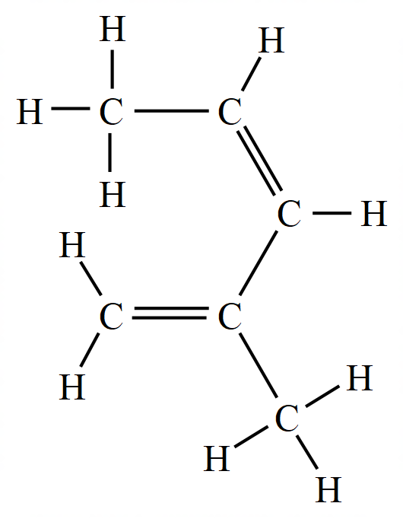
(b) | 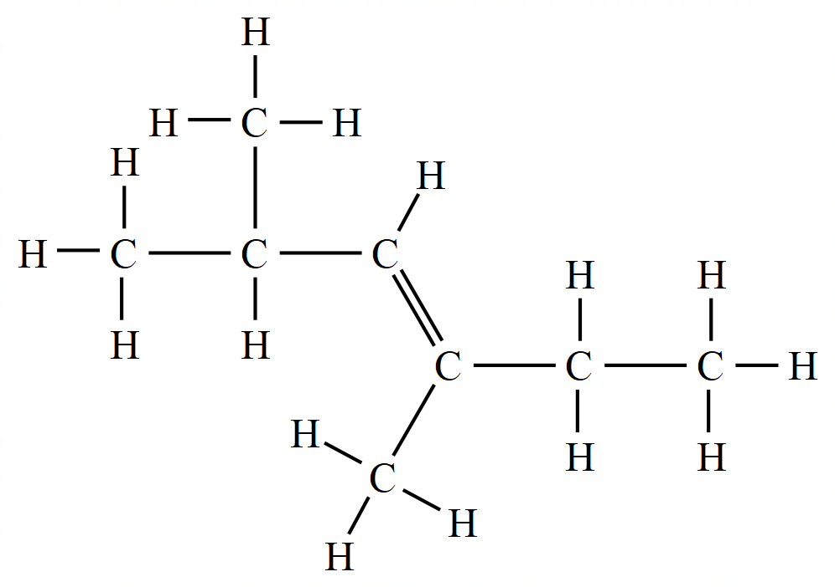
(c) | 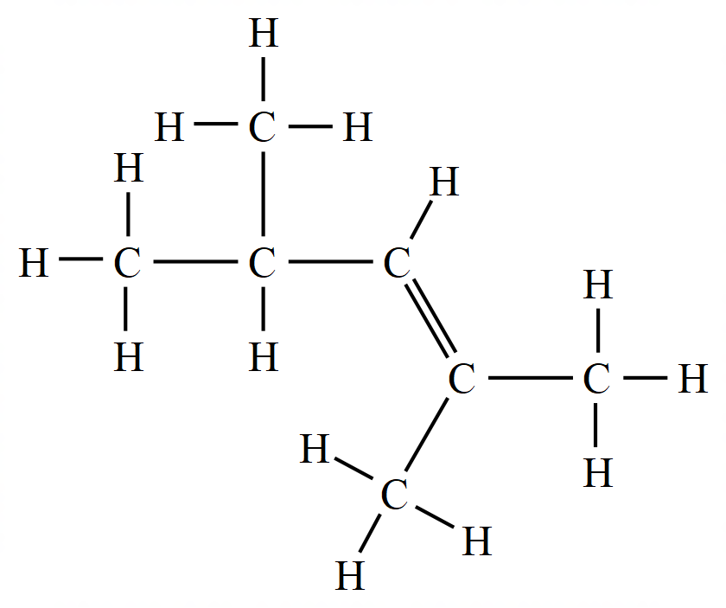
(d) | 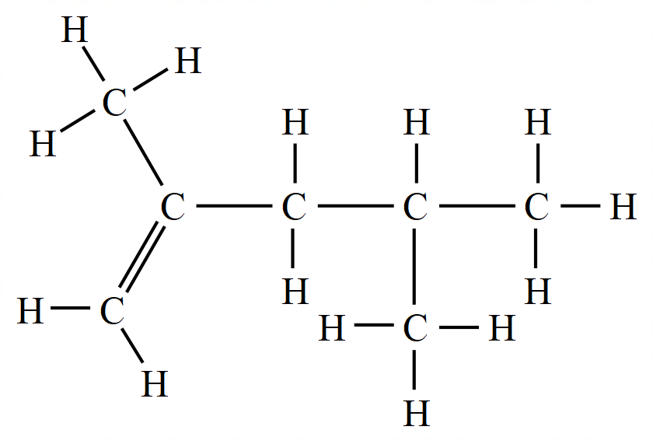

5. Graphite and diamond are allotropes of carbon because:

(a) their atoms are arranged differently
(b) the atoms in each have different numbers of electrons
(c) one has covalent bonds the other has ionic bonds
(d) they form different types of oxides when burnt in air

6. Which one of these is the correct formula for ammonium hydrogen carbonate?

(a) (NH₄)₂CO₃ . H₂O
(b) NH₄HCO₃
(c) (NH₄)₂HCO₃
(d) NH₃HCO₃

7. Which of the following does not have the same number of electrons?

(a) Mg²⁺ and O²⁻
(b) K⁺ and C⁻
(c) Ca²⁺ and Ar
(d) H⁺ and He

8. Bonding in the solid ammonium nitrate involves:

- Ionic bonds
- Covalent bonds
- Metallic bonds

(a) I only.
(b) I and II.
(c) II and III.
(d) II only.

9. Which statement about the Group II elements is/are correct?

- Atomic Radii of Group II elements increases down the group
- Electronegativity Group II elements increases down the group
- Ionisation Energy of Group II elements decreases down the group

(a) III only
(b) I and III
(c) II and III
(d) I, II and III

10. Nanoparticles are particles that have a size between 1 – 100 nm. (where 1 nm (nanometre) = 1 × 10⁻⁹ m). Which one of the flowing would be classified as a nanoparticle?

  - a radon atom
  - an octane molecule
  - a particle of gold containing a few thousand atoms
  - a section of the molecular network in piece of graphite

11. Which of the following is most likely to be a pure compound?

(a) a white powder which partially dissolves in pure water
(b) green crystals which melt at exactly 58ºC
(c) blue crystals that melt between 55ºC and 60ºC
(d) a liquid that gives two fractions when distilled

12. Which of the following provides evidence for kinetic particle theory?

(a) a small mass of water produces much larger volume of steam.
(b) a thin layer is formed when an oil drop is placed on water.
(c) all gases may be easily compressed when a force is applied.
(d) the smell of perfume quickly spreads across a room.

13. The solubility of three substances in two different solvents (P and Q) are shown in the table below
Solid | Solvent
Solid | P | Q
Sand | Insoluble | Insoluble
Sulfur | Soluble | Insoluble
Salt | Insoluble | soluble

A mixture of three solids; sand, sulfur and salt are subjected to the following procedures:
- Excess solvent P added to the solid mixture
- Filtered with the residue collected and labelled as X
- Excess solvent Q was then added to residue X
- This was filtered and the filtrate collected and labelled as Y

Which of the following correctly describes filtrate Y:

(a) Y contains salt only
(b) Y contains sand only
(c) Y contains sulfur only
(d) Y contains a mixture of sand and sulfur

14. Select the most correct way to complete this statement:
During the fractional distillation of crude oil the mixture of hydrocarbons…

(a) cools as it rises through the column
(b) is able to be separated due to differing melting points of its components
(c) is separated by selective boiling
(d) is separated due to differing densities

15. A solution of ammonium sulfate reacts with a solution of calcium hydroxide to produce ammonia gas, calcium sulfate and water as outlined in the equation below:

(NH₄)₂SO₄ (aq) + Ca(OH)₂ (aq) → 2 NH₃ (g) + CaSO₄ (s) + 2 H₂O ()

If 4 moles of ammonia gas were collected after completely reacting all of the ammonium sulfate, how many moles of nitrogen must have been present in the ammonium sulfate reactant?

(a) 1 mole
(b) 2 moles
(c) 4 moles
(d) 8 moles

16. When a uranium nitrate salt UO₂(NO₃)₂ is heated it decomposes to yield uranium oxide (U₃O₈), nitrogen dioxide (NO₂) and oxygen (O₂). How many moles of O₂ are obtained from one mole of the salt?

(a) 1/3 moles
(b) 1/2 moles
(c) 2/3 moles
(d) 2 moles

17. Which one of the following pairs of solutions when mixed together will NOT form a precipitate?

(a) sodium nitrate and hydrochloric acid
(b) copper (II) sulfate and sodium hydroxide
(c) silver nitrate and sodium chloride
(d) sodium sulfate and barium chloride

18. The table below gives information about some substances:

Substance | Melting point | Boiling Point | Electrical conductivity |  | Solubility in water
Substance | Melting point | Boiling Point | As solid | As liquid | Solubility in water
P | Low | Low | Poor | Poor | Soluble
Q | High | Very high | Poor | Good | Insoluble
R | High | Very high | Good | Good | Insoluble
S | Very high | Very high | Poor | Poor | Insoluble

Which of the above substances have ionic, covalent, and metallic bonding respectively?

 | Ionic | Covalent | Metallic
(a) | Q | P | R
(b) | Q | R | S
(c) | R | S | Q
(d) | R | P | S

19. Which of the following are arranged in decreasing order of melting points?

(a) C₂ , Br₂ , I₂
(b) Li , Na , K
(c) NaC , N₂ , MgO,
(d) NH₃ , H₂O, HF

20. Which of the following statements is true?

(a) A catalyst lowers both the enthalpy change and the activation energy of a reaction.
(b) A catalyst lowers the enthalpy change of an endothermic reaction but does not alter the activation energy.
(c) The activation energy of an endothermic reaction is always greater than the enthalpy change of the same reaction.
(d) The activation energy of an exothermic reaction is always greater than the enthalpy change of the same reaction.

21. Which statement best explains why coal dust forms an explosive mixture with air.

(a) Powdered coal breaks chemical bonds
(b) Powdered coal catalyses the explosion
(c) Powdered coal has a large surface area
(d) Powdered coal released hydrogen from compounds in coal

22. Which of the following statements about types of acids is true?

(a) carbonic acid is a strong acid
(b) hydrochloric acid is a weak acid
(c) phosphoric acid is a monoprotic acid
(d) sulfuric acid is a diprotic acid

23. Two solutions have pH values of 3.0 and 7.0 respectively. If equal volumes of these solutions are mixed the pH value of the mixture will most likely be:

(a) exactly 3.0
(b) exactly 5.0
(c) slightly higher than 3.0
(d) slightly lower than 7.0

24. Which of the following substances is most commonly used to regulate the pH of soil to ensure optimal crop growth?

(a) bicarbonate of soda
(b) caustic potash
(c) haematite
(d) slaked lime

25. Ethene and Ethane can be best distinguished by which simple test:

(a) bubbling the gas through chlorine water.
(b) bubbling the gas through bromine water.
(c) testing the products of combustion.
(d) adding concentrated sulfuric acid to the gases.

End of Section One
CHEMISTRY

Year 11 Units 1 & 2 Examination, 2018

Multiple Choice Answer Sheet

ANSWERS

Use a blue or black pen. For each question place a cross in the box to indicate your answer. If you make a mistake, shade that square and then place a cross through your new answer. Do not erase or use correction fluid/tape.

1 | a |  | b |  | c |  | d |  | 14 | a |  | b |  | c |  | d
2 | a |  | b |  | c |  | d |  | 15 | a |  | b |  | c |  | d
3 | a |  | b |  | c |  | d |  | 16 | a |  | b |  | c |  | d
4 | a |  | b |  | c |  | d |  | 17 | a |  | b |  | c |  | d
5 | a |  | b |  | c |  | d |  | 18 | a |  | b |  | c |  | d
6 | a |  | b |  | c |  | d |  | 19 | a |  | b |  | c |  | d
7 | a |  | b |  | c |  | d |  | 20 | a |  | b |  | c |  | d
8 | a |  | b |  | c |  | d |  | 21 | a |  | b |  | c |  | d
9 | a |  | b |  | c |  | d |  | 22 | a |  | b |  | c |  | d
10 | a |  | b |  | c |  | d |  | 23 | a |  | b |  | c |  | d
11 | a |  | b |  | c |  | d |  | 24 | a |  | b |  | c |  | d
12 | a |  | b |  | c |  | d |  | 25 | a |  | b |  | c |  | d
13 | a |  | b |  | c |  | d

Total / 25
Total / 50

This page has been left blank intentionally

Section Two: Short answer 35% (70 Marks)

This section has 8 questions. Answer all questions. Write your answers in the spaces provided.

When calculating numerical answers, show your working or reasoning clearly. Express numerical answers to the appropriate number of significant figures and include appropriate units where applicable.

Spare pages are included at the end of this booklet. They can be used for planning your responses and/or as additional space if required to continue an answer.
• Planning: If you use the spare pages for planning, indicate this clearly at the top of the page.
• Continuing an answer: If you need to use the space to continue an answer, indicate in the original answer space where the answer is continued, i.e. give the page number. Fill in the number of the question(s) that you are continuing to answer at the top of the page.

Suggested working time: 60 minutes.

Question 26 (15 marks)

(a) Complete the table below by writing the name of the molecule and the name of the main intermolecular force between the molecules.
(6 marks)

Formula | Name | Main type of intermolecular force
H₂O | Water  (or Dihydrogen monoxide) | Hydrogen Bonding
CO | Carbon Monoxide | Dipole-dipole
CH₄ | Methane | Dispersion

(b) Draw electron dot diagrams (Lewis structures), state the shape and polarity for each of the molecules below.
(9 marks)

Formula | Lewis structure | Shape | Is it polar?
AsH₃ | 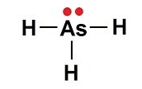 | (Trigonal) Pyramidal | Yes
HCN | H:C:::N: | Linear | Yes
CHC₃ | 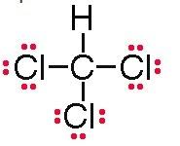 | Tetrahedral | Yes

Description | Marks
Correct Lewis structure showing all bonding pairs and lone pairs  Bonding electrons shown as either : or - | 1 per molecule
Correct shape of molecule | 1 per molecule
Molecules described as polar | 1 per molecule
TOTAL | 9

Question 27 (7 marks)

Consider a hydrocarbon with the molecular formula of C₄H₈.

(a) One of the isomers of has the structure of

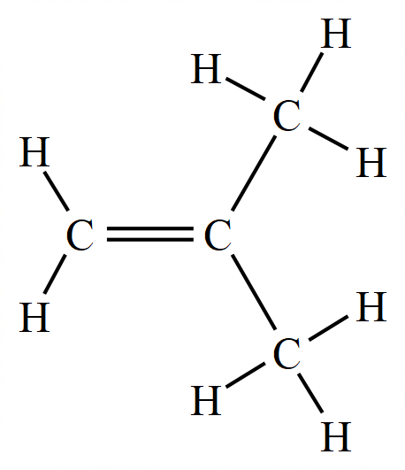
Give the IUPAC name of this compound.
(1 mark)
Description | Marks
Methylpropene (or 2-methylpropene) | 1
TOTAL | 1

(b) Draw a full structural formula and give the IUPAC name for two geometric isomers of the compound. (4 marks)
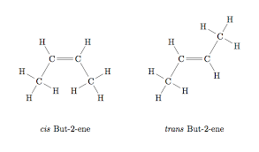
Description | Marks
Molecule drawn shows all atoms and all bonds correctly | 2
Name matches molecule drawn (Error carried forward OK here) | 2
TOTAL | 4

(c) Write balanced equation for the reactions of the compound shown in part (a), C₄H₈, in limited oxygen:
(2 marks)

C₄H₈ (g) + 4 O₂ (g) → 4 CO (g) + 4 H₂O (g)
_________________________________________________________________________

Description | Marks
Equation has correct species | 1
Equation is correctly balanced | 1
TOTAL | 2

Question 28 (6 marks)

The table below summarizes the isotopic composition for argon and potassium:

Element | Atomic Number | Relative atomic Mass | Relative abundance (%)
Argon | 18 | 35.978 | 0.307
Argon | 18 | 37.974 | 0.060
Argon | 18 | 39.974 | 99.633
Potassium | 19 | 38.975 | 93.300
Potassium | 19 | 39.976 | 0.011
Potassium | 19 | 40.974 | 6.690

(a) Determine the relative atomic mass of argon and potassium
(2 marks)
Description | Marks
Ar (Ar) = (35.978 x 0.307)+(37.974 x 0.06) +(39.974 x 99.633) = 39.96  100 | 1
Ar (K) = (38.975 x 93.3) + (39.976 x 0.011) + (40.974 x 6.69) = 39.11  100 | 1
TOTAL | 2

(b) Explain why the relative atomic mass of argon is larger than that of potassium even though potassium has a larger atomic number
(2 marks)

Description | Marks
Potassium atoms have one more proton than argon atoms. | 1
The most abundant isotope of argon has greater atomic weight than that of the most abundant isotope of potassium | 1
Although potassium atoms have one more proton than argon atoms, the most abundant isotope of argon has 22 neutrons giving it a relative atomic mass close to 40. The most abundant isotope of potassium has only 20 neutrons giving it a relative atomic mass of about 39
TOTAL | 2

(c) Account for any slight discrepancies between the calculated atomic masses and those stated in the data sheet for argon and potassium.
(2 marks)

Description | Marks
Natural variation in populations of atoms sampled for this analysis. | 1
Comment regarding sensitivities in measuring devices/equipment | 1
TOTAL | 2

Question 29 (8 marks)

The solubility in water of cobalt (II) nitrate hexahydrate (Co(NO₃)₂.6H₂O) is approximately 134 g/100 mL at 25 ºC.

(a) Determine the concentration of cobalt ions (in mol L⁻¹) when 241 g of solid Co(NO₃)₂.6H₂O is agitated in 150 mL of distilled water at 25ºC - assume no volume change by the displacement by the solid.
(3 marks)

Description | Marks
Only 201g will dissolve in 150 mL at 25⁰C (according to solubility data 134g dissolve in 100mL at 25⁰C) | 1
M_{w} (Co(NO₃)₂.6H₂O) = 58.93 + 2 x 62 + 6 x18 = 290.95  n(Co²⁺) = n((Co(NO₃)₂.6H₂O) = 201 / 290.95 = 0.6908 mol | 1
[Co²⁺] = 0.6908/0.15 = 4.60 mol L⁻¹ (sig figs not penalised) | 1
TOTAL | 3

(b) State and explain why this combination of compounds can be classified as saturated, unsaturated or supersaturated?
(2 marks)
Description | Marks
Saturated | 1
Any clear and reasonable justification using data  Eg: More mass dissolved in 150 mL than would be required to make 100 mL of saturated solution. | 1
TOTAL | 2

(c) Describe all the types of bonding present between particles in the solution of
cobalt (II) nitrate hexahydrate.
(3 marks)
Description | Marks
Ion – dipole bonding between ions and water | 1
Hydrogen bonding between water molecules | 1
Dispersion forces between all particles  Can also include dipole – dipole forces, but not required for mark | 1
TOTAL | 3

Question 30 (6 marks)
Provide full descriptions of what would be observed (including colours of solids/solutions, odours or gases produced) as well as a balanced equation showing only species that participate for the following reactions.

(a) small pieces of nickel metal are placed in 2 mol L⁻¹ hydrobromic acid (HBr).
(3 marks)

Description | Marks
Completely correct ionic equation with state symbols  Ni (s) + 2 H⁺ (aq) → Ni²⁺ (aq) + H₂ (g) | 2
Correct balanced molecular equation with state symbols  OR Incorrectly balanced ionic equation with state symbols  OR Correct balanced ionic equation without all state symbols | 1
Green solution and bubbles produced (not identifying the type of gas) | 1
TOTAL | 3

(b) A 2 g sample of powdered copper carbonate is treated with excess 1.0 mol L⁻¹ hydrochloric acid
(3 marks)
Description | Marks
Completely correct ionic equation with state symbols  CuCO₃ (s) + 2 H⁺ (aq) → Cu²⁺ (aq) + CO₂ (g) + H₂O (l) | 2
Correct balanced molecular equation with state symbols  OR Incorrectly balanced ionic equation with state symbols  OR Correct balanced ionic equation without all state symbols | 1
Green solid produces bubbles and blue solution (must have all three) | 1
TOTAL | 3

Question 31 (8 marks)
Calculate the pH of the following solutions:

(a) 1.93 x 10⁻⁴ mol L⁻¹ hydrochloric acid (1 mark)
Description | Marks
pH = - log [H⁺] = - log (1.93 x 10⁻⁴) = 3.71 (sig figs not penalised) | 1
TOTAL | 1

(b) 0.00875 mol L⁻¹ sodium hydroxide solution
(2 marks)
Description | Marks
[H⁺] = K_{w} / [OH⁻] = 10⁻¹⁴ / 0.00875 = 1.14 x 10⁻¹² mol L⁻¹ | 1
pH = - log [H⁺] = - log (1.14 x 10⁻¹²) = 11.94 (sig figs not penalised)  OR  pOH = -log(0.00875) = 2.058 … (1)  pH = 14-pOH = 14-2.058 = 11.94 … (2) | 1
TOTAL | 2

(c) A solution made by mixing 25.0 mL of 6.68 x 10⁻⁴ mol L⁻¹ sulfuric acid and 15.0 mL of 8.31 x 10⁻⁵ mol L⁻¹ potassium hydroxide solution, giving your answer to the appropriate number of significant figures.
(5 marks)
Description | Marks
n (H₂SO₄) = cV = 6.68 x 10⁻⁴ x 0.025 = 1.67 x 10⁻⁵ mol | 1
n (H⁺) = 2 n (H₂SO₄) = 3.34 x 10⁻⁵ mol | 1
n (OH⁻) = (KOH) = cV = 8.31 x 10⁻⁵ x 0.015 = 1.25 x 10⁻⁶ mol | 1
H⁺ in excess:  n (H⁺) excess = 3.34 x 10⁻⁵ - 1.25 x 10⁻⁶ = 3.215 x 10⁻⁵ mol  c(H+) excess = 3.215 x 10⁻⁵ mol / 0.04 = 8.0375 x 10⁻⁴ | 1
pH = - log [H⁺] = - log (8.0375 x 10⁻⁴) = 3.09  Answer must be to 3 sig figs (-1) | 1
TOTAL | 5

Question 32 (12 marks)

The following table gives some information about several elements in the fourth row of the periodic table:

Element | Melting Point  (ºC) | Electrical conductivity | Melting point of its chloride (ºC)
Potassium | 63 | Very High | KC = 770
Chromium | 1857 | High | CrC₃ = 1150
Selenium | 221 | Low | SeC₄ = - 69
Bromine | -7 | Non-conductive | BrC = - 66

(a) Describe the type of bonding that is present in each of the row four elements that account for the range of melting points.
(4 marks)

Description  Comments addressing the following concepts: | Marks
K a Group 1 metal. Highly metallic with delocalised electrons that from strong forces of attraction between positively charged atoms and negatively charged delocalised electrons. Melting point lower than Cr due to smaller force of attraction that are proportionate to a smaller mass. | 1
Cr a transition metal. Highly metallic with delocalised electrons that form strong forces of attraction between positively charged atoms and negatively charged delocalised electrons. | 1
Selenium a metalloid. Some metallic bonding character but not as strong as a transition metal due to less positive (due to more electrons) nucleus relative to the delocalised electron. | 1
Br₂ a non-metal with covalent bonds that has weak intermolecular forces as there is are only small temporary dipole charges. | 1
TOTAL | 4

Many students describing the bonding in the chlorides rather than the elements – this was awarded 0 as it did not answer the question

Many students simply naming the bonding types. 1 overall

Few students were able to infer the metalloid behaviour of Selenium…….
(b) Using labelled diagrams describe the electrical conductivity of potassium and bromine (as Br₂).
(4 marks)
Description | Marks
Diagram depicting potassium having delocalised valence electrons (negatively charged) surrounding positively charged potassium nuclei | 1
Statement indicating electrical conductivity possible as electrons are free to move when a current is passed through. | 1
Diagram depicting Br₂ as a diatomic molecule with a covalent bond (a Lewis diagram) | 1
Statement that there are no charged species that are free to move when a current is passed through. | 1
TOTAL | 4

Students would be better to say no mobile charge carriers for Bromine than no delocalised electrons……

(c) Using labelled diagrams account for the data that is given for the differing melting points between the chlorides of potassium and bromine.
(4 marks)

Description | Marks
Diagram depicting potassium chloride bonded in an ionic lattice with one K ion of each Cl ion. | 1
Statement indicating ionic bond is very strong and requires great amount of energy to overcome. | 1
Diagram depicting BrCl as a diatomic molecule with weak dipole between one molecule an adjacent molecule | 1
Statement that the intermolecular forces are weak (or easily overcome) by small amount of energy (heat). | 1
TOTAL | 4

Many students describing the elements rather than the chlorides… Zero awarded as it did not answer the question

Question 33 (8 marks)

Nitrogen dioxide can be prepared from the addition of concentrated nitric acid with pure copper metal:

Cu (s) + 4 HNO₃ (aq) → Cu(NO₃)₂ (aq) + 2 H₂O (ℓ) + 2 NO₂ (g)

(a) Determine the Limiting Reagent when 150.0 mL of 14.0 mol L⁻¹ HNO₃ and 242 g of copper metal are combined at STP.
(4 marks)
Description | Marks
n(HNO₃) = cV = 14 x 0.15 = 2.1 mol | 1
n(Cu) = 242 / 63.55 = 3.808 mol | 1
Stoic mole ratio of HNO₃ : Cu is 4:1  Actual ratio HNO₃ : Cu is (3.808/2.1) ie - 1.8 : 1  [Or similar logic statement] | 1
Comment that Limiting reagent is HNO₃ | 1
TOTAL | 4

(b) Calculate the volume of nitrogen dioxide that would be generated at STP from this reaction.
(1 mark)
Description | Marks
V(NO₂) = ½ x n(HNO₃) x 22.71 = ½ x 2.1 x 22.71 = 23.85L | 1
TOTAL | 1

(c) Calculate the mass of unused reactant that remains after this reaction has gone to completion.
(3 marks)
Description | Marks
n(Cu consumed) = ¼ x n(HNO₃) = ¼ x 2.1 = 0.525 mol | 1
n(Cu remain) = 3.808 – 0.525 = 3.283 mol  OR m(Cu consumed = 0.525 x 63.55 = 33.36g | 1
m(Cu remain) = 3.285 x 63.55 = 208.6g  OR m(Cu remain) = 242 – 33.36 = 208.6g | 1
TOTAL | 3
Common mistake – not using ¼ - 1 or 2 marks depending on clarity of working
End of Section Two
Section Three: Extended answer 40% (80 Marks)

This section contains 5 questions. You must answer all questions. Write your answers in the spaces provided.

Where questions require an explanation and/or description, marks are awarded for the relevant chemical content and also for coherence and clarity of expression. Lists or dot points are unlikely to gain full marks.

Final answers to calculations should be expressed to the appropriate number of significant figures.

Spare pages are included at the end of this booklet. They can be used for planning your responses and/or as additional space if required to continue an answer.
• Planning: If you use the spare pages for planning, indicate this clearly at the top of the
page.
• Continuing an answer: If you need to use the space to continue an answer, indicate in the original answer space where the answer is continued, i.e. give the page number. Fill in the number of the question(s) that you are continuing to answer at the top of the page.

Suggested working time: 70 minutes.

Question 34 (22 marks)

The Pilbara region in Western Australia is one of the leading iron ore producing areas in the world. The ore that is mined contains a number of minerals, including hematite, magnetite, and titano-magnetite.

The development of coke blast furnaces (as opposed to charcoal) in 1709 enabled much more efficient extraction of iron ores. This method of extraction changed relatively little up to the 21st century. Kwinana is now the site of a new HIsmelt iron production plant, which, it is envisaged, will one day produce up to 800,000 tonnes of iron each year.

The technology promises to offer a lower cost and cleaner alternative to the traditional blast furnace process, but the chemical reactions taking place are largely similar. In the smelter, fine iron ore and coal are injected directly into a bath of molten iron. Here, the carbon dissolves in the molten metal, and reacts with iron oxides to produce iron and carbon monoxide at about 1450ºC.

The equation for the reaction taking place between the carbon and iron oxide is below:.

Fe₂O₃ (s) + 3 C (s) → 2 Fe () + 3 CO (g)

The diagram below shows the design of a HIsmelt furnace.

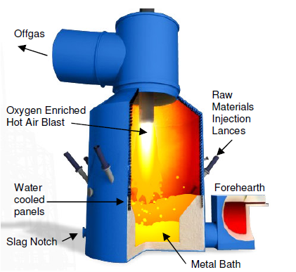

- Explain, using collision theory, why it is important that the iron ore and coke are finely divided when they enter the molten iron bath at the bottom of the furnace.
(2 marks)

Description | Marks
Increase Surface Area that enables greater frequency of successful collisions with sufficient energy to react. | 1
Faster reaction Rate | 1
TOTAL | 2

Must explain that an increase in surface area results in more collisions.

The rapid expulsion of carbon monoxide causes a fountain of molten metal and slag droplets to rise up inside the furnace. A hot air blast is used to combust the carbon monoxide released by the bath reactions. The air in the blast is enriched with up to 35% oxygen to aid this combustion.

- Explain, using collision theory, what effect the enrichment of the oxygen content has on the rate of reaction between the gases.
(2 marks)
Description | Marks
Increases concentration of reactants | 1
Increases reaction rate converting carbon monoxide to carbon dioxide | 1
TOTAL | 2

The equation for the reaction between carbon monoxide and oxygen is shown below:

2CO_{(g)} + O_{2(g)}→ 2CO_{2(g)} ∆H = - 566 kJmol⁻¹

- On the axes below, draw an energy level diagram for the reaction. Ensure that you label the axes, reactants and products, and the enthalpy change clearly.
(3 marks)

Description | Marks
Y axes labels – energy (kJ mol⁻¹) | 1
Reactants at energy greater than products | 1
Difference between reactants and products is labelled as ∆H = - 566 kJmol⁻¹ | 1
TOTAL | 3

Y axis must be labelled correctly with units, and enthalpy change must be denoted on the graph in full with units.

It is important that the air in the blast is heated to ensure a satisfactory rate of reaction between the gases in the smelter. The following graph shows the energies of molecules in the gas mixture at temperatures such as those used (around 1450ºC).

- Sketch on the graph what effect using a lower temperature would have on the energy of the particles. (1 mark)

% of particles

1450ºC

Kinetic energy (kJ)

Description | Marks
Peak is higher and more to left | 1
TOTAL | 1

A mark is given for a reasonable response.

- Use the data from the graph in part (d) to explain why the rate would be slower if the blast were not heated.
(3 marks)
Description | Marks
Fewer portion of particles will have energy greater than activation energy | 1
More particles will have less average kinetic energy (or velocity) – lower E_{k} (ave) | 1
At lower velocities particles are less likely to collide (or there are fewer number of collisions) | 1
TOTAL | 3

- Less kinetic energy (velocity)
- Less frequent collisions
- Less successful collisions as less particles reach Ea.
Some students answered the question for an increase in temperature, which is not answering the question asked. 0-1 marks.

One of the advantages of the HIsmelt process compared to traditional blast furnace methods of extraction is the flexibility it offers with regard to ores used, meaning less processing is required. 1000 kg of direct shipping iron ore, containing 65% Fe₂O₃, is fed into the furnace, together with 200 kg of coal.

- Find the limiting reagent (assume the coal is 100% carbon). (5 marks)

Description | Marks
m(Fe₂O₃) = 0.65 x 1000 = 650 kg | 1
n(Fe₂O₃) = 650 / 159.7 = 4.07 kmol (4070 mol) | 1
n(C) = 200 / 12 = 16.67 kmol (16653 mol) | 1
Stoic ratio C : Fe₂O₃ is 3:1  Actual ratio is (16.67/4.07) : (4.07/4.07) = 4:1  [Or similar logic statements] | 1
Limiting Reagent is Fe₂O₃ | 1
TOTAL | 5

Must have correct units for mass and moles (i.e. kmol vs mol)
Must have an appropriate justification for the choice of L.R.

- What mass of molten iron would be formed in the reaction?
(2 marks)

Description | Marks
n(Fe) = 2 x n(Fe₂O₃) = 2 x 4.07 = 8.14 kmol | 1
m(Fe) = 8.14 x 55.85 = 455 kg | 1
TOTAL | 2

- The smelter is run at 120 kPa and 1450ºC. What volume of carbon monoxide would form in the smelter if the volume of carbon monoxide at these conditions occupies 119.4 L mol⁻¹ ?
(2 marks)

Description | Marks
n(CO) = 3 x n(Fe₂O₃) = 3 x 4.07 = 12.21 kmol | 1
V(CO) = 12.21 x 119.4 = 1458 kL  [Recognise that n = V / 119.4] | 1
TOTAL | 2

Some students applied PV = nRT appropriately and were awarded marks.

- What volume of enriched air would need to be blasted into the furnace to provide the oxygen for the combustion of this carbon monoxide (you may assume the air is at the same temperature and pressure as the gases in the furnace)? (2 marks)

Description | Marks
n(O₂) = ½ x n(CO) = ½ x 12.21 = 6.105 kmol  V(O₂)) = 6.105 x 119.4 = 729 kL  [Recognise that n = V / 119.4] | 1
V(air) = 100/35 x 729 = 2083 kL  [recognise air is enriched to contain 35% O₂] | 1
TOTAL | 2

Many students did not recognise that it was 35% O₂.

Question 35 (13 marks)

Caproic acid is the chemical responsible for the smell of dirty socks and is composed of carbon, hydrogen and oxygen only. It is a weak, monoprotic acid. A 0.531 g sample of the acid was combusted to produce 1.21 g of carbon dioxide and 0.493 g of water.

(a) Determine the empirical formula for the acid
(6 marks)

Description | Marks
Calculates mass carbon  n(CO₂) = 1.21 / 44.01  = 0.0275 mol  m(C) = 0.0275 x 12.01  = 0.3302 g | 1
Calculates mass hydrogen  n(H2O) = 0.493 / 18.016  = 0.0274 mol  [n(H) = 2 x 0.0274 = 0.0547 mol]  m(H) = 2 x 1.008 x 0.0274  = 0.0552 g | 1
Calculates mass oxygen  m(O) = 0.531 - (0.3303 + (5.52 x 10⁻²))  = 0.146 g | 1
Calculates moles oxygen  n(O) = 0.146 / 16.00  = 0.00912 mol | 1
Determines C: H: O  Moles 0.0275 0.0552 0.00912  Ratio ( / 0.00912) 3 6 1 | 1
States empirical formula is C₃H₆O | 1
Error carried forward marks allocated
TOTAL | 6

(b) Given that the molar mass of caproic acid is 116 g mol⁻¹, determine the molecular formula of the acid.
(3 marks)

Description | Marks
Calculates empirical formula mass  EFM = 58.058 | 1
Calculates ratio MFM:EFM  MFM / EFM = 116 / 58.058 = 2 | 1
States molecular formula is C₆H₁₂O₂ | 1
Error carried forward marks allocated
TOTAL | 3

(c) Zinc oxide can be used as a foot powder to reduce the smell. Write an equation for the reaction between zinc oxide and caproic acid solution. Hint: caproic acid is monoprotic.
(2 marks)
Description | Marks
Correct balanced formulae  2C₆H₁₂O₁₂ + ZnO → 2C₆H₁₁O ⁻ + Zn²⁺ + H₂O  OR 2C₆H₁₂O₁₂ + ZnO → Zn(C₆H₁₁O)₂ + H₂O | 2
Correct formula not balanced  OR  Balanced: ZnO + 2H⁺ → Zn²⁺ + H₂O | 1
TOTAL | 2

(d) Caproic acid, like ethanoic acid is considered a weak acid. Explain why this is the case and what affect this has on the concentration of hydrogen ions that are available to react.
(2 marks)
Description | Marks
Weak acid (does not completely dissociate/ionise) | 1
Lower [H⁺] | 1
TOTAL | 2

This page has been left blank intentionally

Question 36 (25 marks)

Barium is a highly toxic substance to higher animals and can accumulate in animal and plant tissue. High barium levels can affect the ability of plants to photosynthesize, and in higher animals can cause heart disease, respiratory failure, kidney damage, and muscle weakness. Student chemists were interested in determining the concentration of barium (II) ions in a large water pond outside of a glass making factory.

The basic technique involved adding sodium sulfate (Na₂SO₄) to a 500.0 mL water sample to precipitate out the barium as barium (II) sulfate. The acceptable level of barium in drinking water is 2.0 mg/L. Levels above 50 mg/L are considered to be immediately dangerous to life and health.

- Write a balanced equation (containing only species participating) for the precipitation reaction.
(1 mark)

Description | Marks
Ba²⁺ (aq) + SO₄²⁻ (aq) → BaSO₄ (s) | 1
Must include state symbols and ionic charges
TOTAL | 1

The barium sulfate precipitate was collected and placed in a special oven at 110ºC. Over time the sample was weighed and re-weighed. (1 g = 1000 mg)
Weighing | Mass (mg)
1 | 23.0
2 | 21.5
3 | 19.0
4 | 19.0

- Why was the sample weighed four times?
(1 mark)
Description | Marks
Ensured all water of hydration removed/evaporated. | 1
TOTAL | 1

(c) Calculate the mass of barium in mg in the precipitate. (2 marks)

Description | Marks
m(BaSO₄) recovered = 19.0 mg | 1
m(Ba) = (19 x 137.3) / 233.36 = 11.2 mg  Must be in mg | 1
TOTAL | 2

(d) Determine the concentration of barium ions (in mg/L), in the polluted water sample. (Assume the density of the water is 1000 mg/L)
(2 marks)

Description | Marks
[Ba²⁺] = 11.2 / 0.5  = 22.4 mg/L | 2
Missing units or not in mg/L | 1
Error carried forward marks allocated
TOTAL | 2

(e) How does the concentration of barium ions in the water sample compare with the accepted level in drinking water?
(1 mark)

Description | Marks
The concentration of barium ions is greater than accepted level in drinking water. | 1
TOTAL | 1

(f) The students assumed that no other ions in the water formed precipitates with the sodium sulfate solution.

(i) Name ONE other ion that would also form a precipitate with sulfate ions? (1 mark)

Description | Marks
Other ions which also form precipitates include Pb²⁺, Ca²⁺, Sr²⁺ and Ag⁺ (only one needed) | 1
TOTAL | 1

(ii) Write the balanced ionic equation for the reaction of this ion that forms a precipitate with sodium sulfate solution. (2 marks)
Description | Marks
Ion from (i) (aq) + SO₄²⁻ (aq) → from(i)SO₄ (s) | 2
Not balanced or missing state symbols or missing ionic charges or with spectators | 1
TOTAL | 1

After this preliminary result, the students decided to extend their investigation over a number of weeks to see how barium levels changed over time, and so tested more water samples. Their results are tabulated below:

Day | Concentration of Barium ions (mg/mL)
0 | Answer in (d)
3 | 30
6 | 36
9 | 45
12 | 60
15 | 55
18 | 58

(g) For this extended investigation what was the:
(2 marks)
Description | Marks
Independent Variable - Time | 1
Dependant Variable – Barium ion Concentration | 1
TOTAL | 2

(h) State two (2) variables that would need to be controlled? (2 marks)
Description | Marks
Sampling Technique:  - Sampling (400 mL) from the same spot in the pond  - Period of time with no rainfall  - No other influences [another industry] | 1
Laboratory work needs to be consistent and accurate:  - Method of filtering and drying precipitate  - Same weighing balance | 1
TOTAL | 2

(i) What safety measures should be used when handling the barium samples?
(2 marks)

Description | Marks
Safety glasses | 1
Gloves / breathing mask | 1
TOTAL | 2

(i) Plot the information on the graph paper below. Include a heading and all labels.
(5 marks)

Description | Marks
Heading | 1
Axes labelled with units | 1
Scale - reasonable | 1
Correct axes (y – [Ba²⁺] , x – time) | 1
Line of best fit | 1
TOTAL | 5

(k) What conclusions can be made from this investigation?
(2 marks)

Description | Marks
Any two from:  - [Ba²⁺] were at a dangerous level (above 50 mg/L) from day 10.  - [Ba²⁺] generally increased over the time period  - [Ba²⁺] fluctuated over the time period  - Water quality not suitable for human consumption Heading | 2
TOTAL | 2

(l) Describe TWO possible impacts on the environment that high levels of barium from this factory may have?
(2 marks)

Description | Marks
Any two from:  - Loss of flora and fauna  - Food chains/webs changed  - Health of animals affected | 2
TOTAL | 2

Question 37 (20 marks)

Benzene (C₆H₆) can be converted to cyclohexane (C₆H₁₂)

by the addition of hydrogen gas. The reaction can be catalysed using metallic nanoparticles.

(a) Using kinetic theory and an appropriate diagram, explain how a catalyst can speed up the rate of the chemical reaction.
(4 marks)
Description | Marks
A catalyst provides an alternative reaction pathway with a lower activation energy | 1
Reactants  Reaction Progress  H  Products  un-catalysed reaction  catalysed reaction  E_{A}  E_{A}  Could also accept a fully labelled energy distribution diagram showing two positions for the activation energy, catalysed and non-catalysed | 1-2
Higher proportion of successful collisions / collisions with sufficient energy / collisions with greater than the activation energy | 1
Total | 4

Little tolerance was allowed in this question regarding the marks allocated.
Students in general provided a diagram which was below the expected level of detail.

(b) Using collision theory, explain why the metal catalyst is more effective in the form of nanoparticles than in the bulk form (larger pieces) of the metal.
(2 marks)

Description | Marks
Greater surface area in the nanoparticles | 1
More chance of a collisions with the (metal) catalyst | 1
Total | 2

No tolerance. Must have these two points.

(c) Write a balanced chemical equation for this reaction.
(1 mark)
Description | Marks
C₆H₆ + 3 H₂ → C₆H₁₂ | 1
Total | 1

(d) Calculate the mass of cyclohexane that can be produced from 1750 g of benzene.
(3 marks)

Description | Marks
n(C₆H₆) = m /M = 1750 / 78.108 = 22.405 mol | 1
n(C₆H₁₂) = n(C₆H₆) = 22.405 mol | 1
m( C₆H₁₂) = n × M = 22.405 × 84.156 = 1886 g | 1
Total | 3

(e) (i) Calculate the mass of hydrogen gas that would be required for this reaction.
(2 marks)

Description | Marks
n(H₂) = (3/1) × n(C₆H₆) = 3 × 22.405 = 67.215 mol | 1
m(H₂) = n × M = 67.215 × 2.016 = 136 g | 1
Total | 2

(ii) Calculate the volume of this amount of hydrogen gas at standard temperature and pressure (STP).
(2 marks)

Description | Marks
V = n × 22.71 = 67.215 × 22.71 = 1.53 x 10³ L (OR 1.53 kL) | 1
Answer to 3 sig figures and correct units (for both answers in part (e)) | 1
Total | 2

Both answers for part e must have 3 sig figs for the last mark.
(f) During this process, the chemical engineer was concerned that cyclohexene (C₆H₁₀) might be formed in place of the cyclohexane.

(i) Describe a chemical test, including expected observations, that would detect the presence of cyclohexene in the products of this reaction.
(2 marks)

Description | Marks
Add bromine water / aqueous bromine to the products of the reaction  or:  Add acidified potassium permanganate solution to the products of the reaction | 1
If cyclohexene present, bromine water will decolourise / go from orange to colourless  or:  If cyclohexene present, potassium permanganate solution will decolourise / go from purple to colourless | 1
Total | 2

No student used potassium permanganate.
Must have underlined explanation for the second mark. Little tolerance.

(ii) With reference to the equation in part (c), suggest how the chemical engineer can reduce the risk of cyclohexene being formed in the reaction.
(1 mark)

Description | Marks
Ensure that there is enough hydrogen present/supplied | 1
Total | 1
(g) The percentage by mass of carbon in cyclohexane is 85.8%

(i) Calculate the percentage by mass of carbon in benzene
(1 mark)

Description | Marks
M(C₆H₆) = ((6 × 12.01) / 78.108) x100 = = 92.3 % | 1
Total | 1

92.4% was not accepted as working was incorrect.

(ii) Use you answer to (g) (i) to suggest why aromatic substances such as benzene burn with a more smoky flame than aliphatic compounds such as cyclohexane.
(2 marks)

Description | Marks
Smoke in flames is caused by (unburnt) carbon | 1
Aromatic compounds have a higher percentage of carbon than aliphatic compounds (therefore more likely to have unreacted carbon after combustion) | 1
Total | 2

Many students were unable to recognise that the soot was unburned C.
Some tolerance was allowed for good Chemistry responses.

End of questions
Additional Working Space

__________________________________________________________________________________________

__________________________________________________________________________________________

__________________________________________________________________________________________

__________________________________________________________________________________________

__________________________________________________________________________________________

__________________________________________________________________________________________

__________________________________________________________________________________________

__________________________________________________________________________________________

__________________________________________________________________________________________

__________________________________________________________________________________________

__________________________________________________________________________________________

__________________________________________________________________________________________

__________________________________________________________________________________________

__________________________________________________________________________________________

__________________________________________________________________________________________

__________________________________________________________________________________________

__________________________________________________________________________________________

__________________________________________________________________________________________

__________________________________________________________________________________________

__________________________________________________________________________________________

__________________________________________________________________________________________

__________________________________________________________________________________________

__________________________________________________________________________________________

__________________________________________________________________________________________

__________________________________________________________________________________________

Spare grid for Question 36

Additional Working Space

__________________________________________________________________________________________

__________________________________________________________________________________________

__________________________________________________________________________________________

__________________________________________________________________________________________

__________________________________________________________________________________________

__________________________________________________________________________________________

__________________________________________________________________________________________

__________________________________________________________________________________________

__________________________________________________________________________________________

__________________________________________________________________________________________

__________________________________________________________________________________________

__________________________________________________________________________________________

__________________________________________________________________________________________

__________________________________________________________________________________________

__________________________________________________________________________________________

__________________________________________________________________________________________

__________________________________________________________________________________________

__________________________________________________________________________________________

__________________________________________________________________________________________

__________________________________________________________________________________________

__________________________________________________________________________________________

__________________________________________________________________________________________

__________________________________________________________________________________________

__________________________________________________________________________________________

__________________________________________________________________________________________

Additional Working Space

__________________________________________________________________________________________

__________________________________________________________________________________________

__________________________________________________________________________________________

__________________________________________________________________________________________

__________________________________________________________________________________________

__________________________________________________________________________________________

__________________________________________________________________________________________

__________________________________________________________________________________________

__________________________________________________________________________________________

__________________________________________________________________________________________

__________________________________________________________________________________________

__________________________________________________________________________________________

__________________________________________________________________________________________

__________________________________________________________________________________________

__________________________________________________________________________________________

__________________________________________________________________________________________

__________________________________________________________________________________________

__________________________________________________________________________________________

__________________________________________________________________________________________

__________________________________________________________________________________________

__________________________________________________________________________________________

__________________________________________________________________________________________

__________________________________________________________________________________________

__________________________________________________________________________________________

__________________________________________________________________________________________

